Based on RASPBIAN JESSIE
Version: March 2016
Release date: 2016-03-18
Kernel version: 4.1

HDMI setting
<1> To ensure that the necessary kernel modules are loaded at boot
pi@raspberrypi ~ $ sudo nano /boot/config.txt
<2> Uncomment following three lines in config.txt by removing '#' located at start of the line. (check Images below)
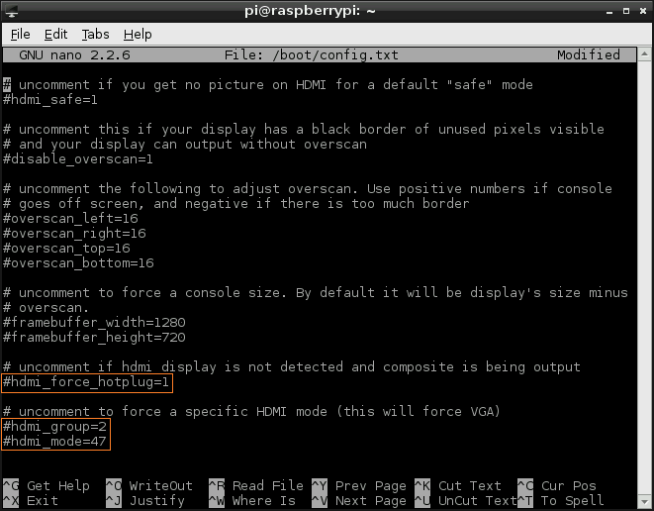
hdmi_force_hotplug=1 pretends that HDMI device is always attached
hdmi_group specifies whether monitor is DMT type (Computers) or CEA type (TV)
hdmi_mode specifies the resolution of monitor.
<3> For hdmi_group value selection : If you’re using output as Computer monitor then replace value ’1′ with ’2′, so the new config will be like :
hdmi_group=2
(Select value 1 for TV, Select value 2 for monitor)
<4> For hdmi_mode value selection : Now open eLinux RPi config scroll down, there in hdmi_mode two tables are given, select the correct resolution as per your monitor. (Table1 if you’re using TV & Table2 if you’re using Monitor)
Since my monitor’s resolution is 1440×900 px, hdmi_mode=47 fits me the best. So, the modified config.txt will be like.
hdmi_mode=47
Overall my uncommented lines will look something like :
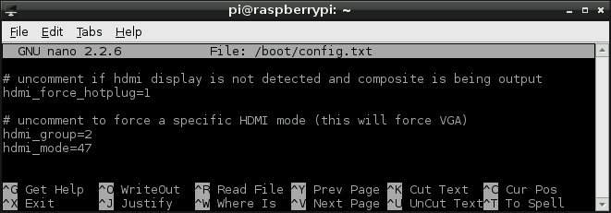
<5> adding the "hdmi_drive=2" line at the bottom
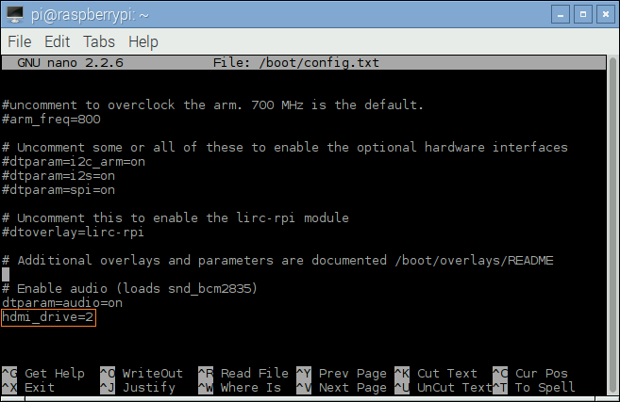
<6> Save your changes by pressing Ctrl-x then Y
<7> Reboot your Raspberry Pi
pi@raspberrypi ~ $ sudo reboot
Based on RASPBIAN JESSIE
Version: March 2016
Release date: 2016-03-18
Kernel version: 4.1
HDMI setting
<1> To ensure that the necessary kernel modules are loaded at boot
pi@raspberrypi ~ $ sudo nano /boot/config.txt
<2> Uncomment following three lines in config.txt by removing '#' located at start of the line. (check Images below)
hdmi_force_hotplug=1 pretends that HDMI device is always attached
hdmi_group specifies whether monitor is DMT type (Computers) or CEA type (TV)
hdmi_mode specifies the resolution of monitor.
<3> For hdmi_group value selection : If you’re using output as Computer monitor then replace value ’1′ with ’2′, so the new config will be like :
hdmi_group=2
(Select value 1 for TV, Select value 2 for monitor)
<4> For hdmi_mode value selection : Now open eLinux RPi config scroll down, there in hdmi_mode two tables are given, select the correct resolution as per your monitor. (Table1 if you’re using TV & Table2 if you’re using Monitor)
Since my monitor’s resolution is 1440×900 px, hdmi_mode=47 fits me the best. So, the modified config.txt will be like.
hdmi_mode=47
Overall my uncommented lines will look something like :
<5> adding the "hdmi_drive=2" line at the bottom
<6> Save your changes by pressing Ctrl-x then Y
<7> Reboot your Raspberry Pi
pi@raspberrypi ~ $ sudo reboot
<8> Mouse right click the speaker icon and select audio output of HDMI
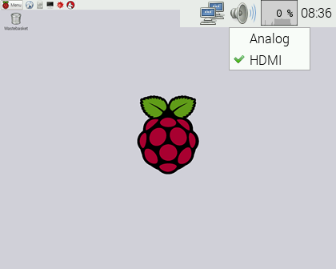
Testing the IR receiver
<9> Installing LIRC
pi@raspberrypi ~ $ sudo apt-get install lirc
<10> Add the two lines below to /etc/modules . This will start the modules up on boot. Pin 8 bellow will be used to take the output from the IR sensor.
pi@raspberrypi ~ $ sudo nano /etc/modules

lirc_dev
lirc_rpi gpio_in_pin=2
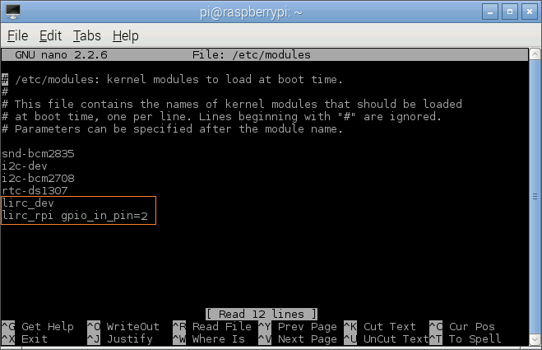
<11> Save your changes by pressing Ctrl-x then Y
<12> If you are using 3.18.x RaspberryPi firmware you must modify one additional file for the lirc-rpi kernel extension to be loaded:
Edit your /boot/config.txt file
pi@raspberrypi ~ $ sudo nano /boot/config.txt

and add:
dtoverlay=lirc-rpi,gpio_in_pin=2
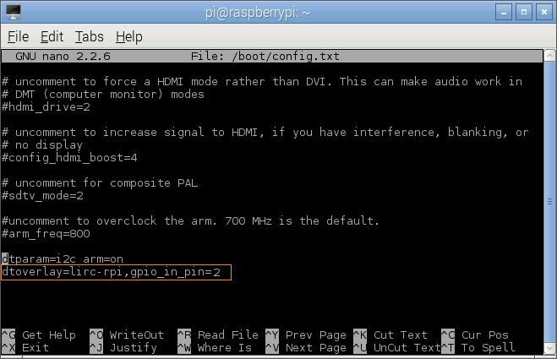
<13> Edit /etc/lirc/hardware.conf and have it appear exactly as shown below.
pi@raspberrypi ~ $ sudo nano /etc/lirc/hardware.conf

# /etc/lirc/hardware.conf
#
# Arguments which will be used when launching lircd
LIRCD_ARGS="--uinput"
# Don't start lircmd even if there seems to be a good config file
# START_LIRCMD=false
# Don't start irexec, even if a good config file seems to exist.
# START_IREXEC=false
# Try to load appropriate kernel modules
LOAD_MODULES=true
# Run "lircd --driver=help" for a list of supported drivers.
DRIVER="default"
# usually /dev/lirc0 is the correct setting for systems using udev
DEVICE="/dev/lirc0"
MODULES="lirc_rpi"
# Default configuration files for your hardware if any
LIRCD_CONF=""
LIRCMD_CONF=""
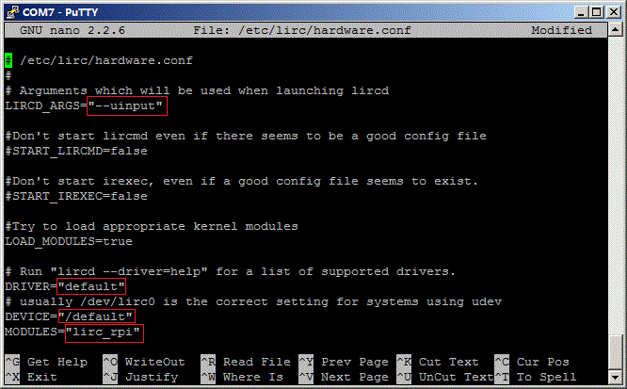
The highlighted text are the parts that will need changing, though it’s worth checking the rest of the text incase you have a different initial configuration.
<14> Save your changes by pressing Ctrl-x then Y
<15> Reboot the Raspberry Pi
pi@raspberrypi ~ $ sudo reboot
<16> Run these two commands to stop lircd and start outputting raw data from the IR receiver:
pi@raspberrypi ~ $ sudo /etc/init.d/lirc stop
pi@raspberrypi ~ $ mode2 -d /dev/lirc0
<17> Point a remote control at your IR receiver and press some buttons. You should see something like this:
