How to Use LCD(sku:443780) to Display the Volumio Information of DAC+ Board?

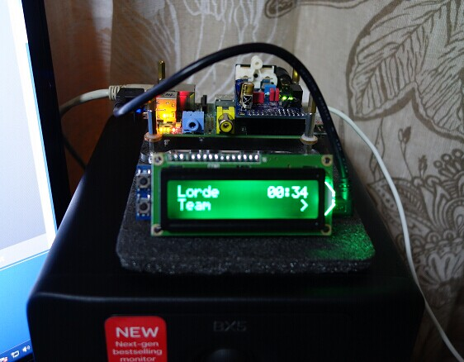

1. Install lcdproc screen display software
sudo apt-get install lcdproc
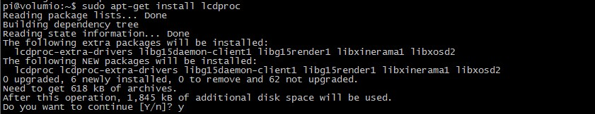

2. Edit configuration files
sudo nano /etc/LCDd.conf

Find the below related content and modify
Driver=curses => Driver=hd44780
#ServerScreen=no => ServerScreen=off

Find [hd44780], changed to the below information:
[hd44780]
ConnectionType=lcd2usb
Contrast=850
Brightness=800
OffBrightness=0
Keypad=yes
Backlight=yes
Size=16×2
KeyDirect_1=Up
KeyDirect_2=Down

PS: You can also download the config file and replace /etc/LCDd.conf directly

4. Install MPDlcd software
sudo apt-get install python-mpd
sudo apt-get install python-pip
sudo pip install mpdlcd
wget -O /etc/mpdlcd.conf https://raw.github.com/rbarrois/mpdlcd/master/mpdlcd.conf

5. Set it to run automatically;
sudo update-rc.d LCDd defaults

Edit /etc/rc.local, add the below command before exit0 line

su volumio -c “mpdlcd –no-syslog &”
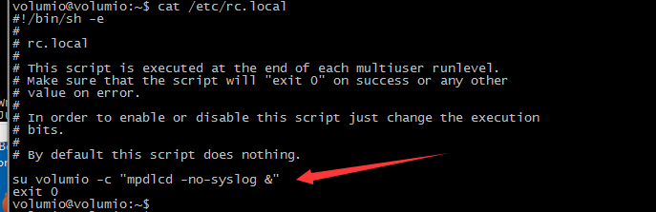

6. Reboot system, then let's us engoy some music now.

7. You can edit the configuration file to set the display comment, only modify the [pattern] comment;
sudo nano /etc/mpdlcd.conf

Some Play effect pictires:
Normal play display effect:
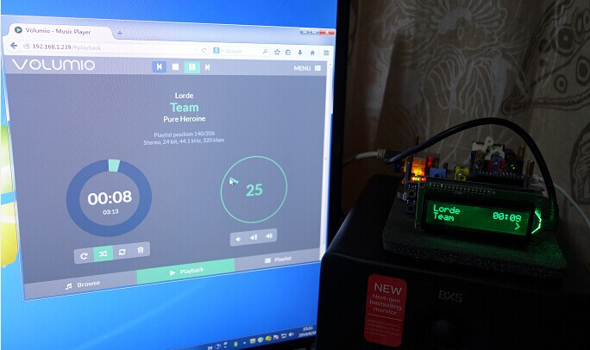

Pause display effect:
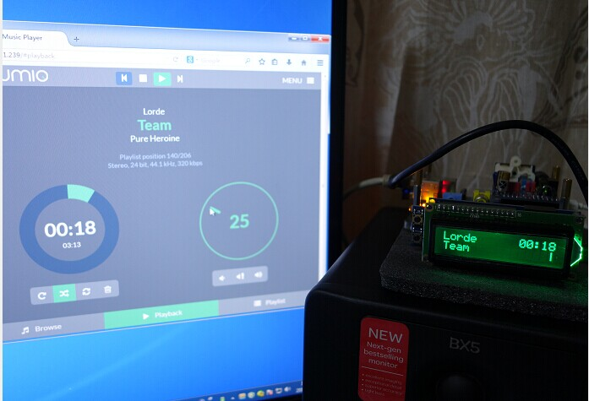
Stop display effect:
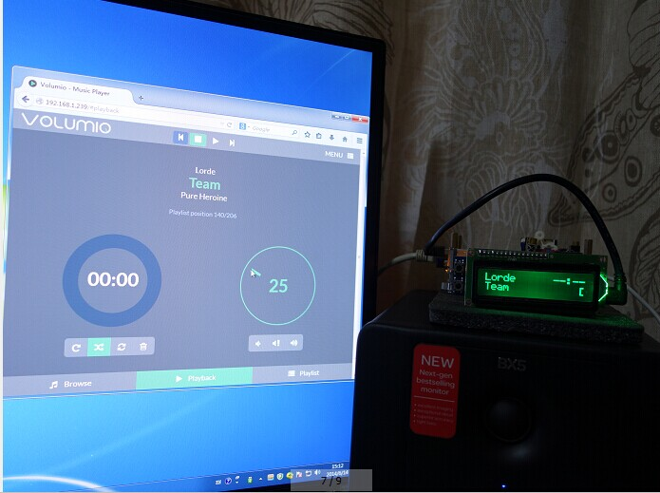

Reference documents:
https://pypi.python.org/pypi/mpdlcd/0.4.0
https://github.com/rbarrois/mpdlcd

