EXP GDC
Laptop External Graphics Adapter DOCK
Operating Guide

Please use the manual to install and use.
Catalog
1、Product overview----------------------------------------------------------------------------------001
2、Hardware installation-----------------------------------------------------------------------------002
3、System configuration and driver installation-----------------------------------------------003
4、Use display settings------------------------------------------------------------------------------003
5、Troubleshooting-----------------------------------------------------------------------------------004
6、System optimization settings-------------------------------------------------------------------006

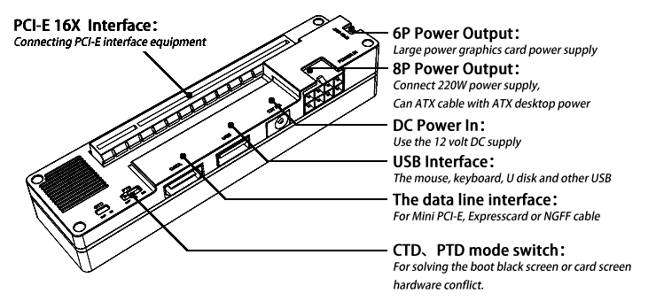
1、Product overview
The PCI-E interface:
Can be connected to any PCI-E interface device,
including graphics, sound card, video card, array,
data acquisition card etc..
6P power output:
The maximum provides the interface output 6PIN+
8PIN, maximum support 12A, maximum support
18A output with the motherboard and the. If more
than 220W using power card please with ATX cable,
ATX power supply used for the graphics.
8P power supply interface:
The main board and the equipment of the power supply interface, support soft switch function (notebook starting power starting, notebook shut down power off). The power of this interface, you can use 1 special DELL 220W, 2, can be matched with ATX cable using the ATX power to support external graphics power, soft switching function.
DC power supply interface:
Support DC 12 volt power supply input interface type outer diameter 5.5MM, inner diameter 2.1MM, maximum power 150W, support the soft switch function.
The USB interface:
Can be connected to the keyboard, mouse, U disk, mobile hard disk and a wireless network card and so on any USB device. Part of the use of MINI PCI-E transfer line computer cannot use this function.
The data line interface:
For Mini PCI-E, Expresscard, NGFF connection or PCI-E X1 cable. This interface is non standard HDMI interface, connect other equipment damage caused by the need to pay.
TD switch:
For solving the conflict due to the soft hardware equipment can not be normal use, by default the switch is located on the left side of the OFF state. External graphics card cases such as notebook boot black screen or card screen PTD please switch to the right. More special function can support customer service and technical consulting.

2、Hardware installation
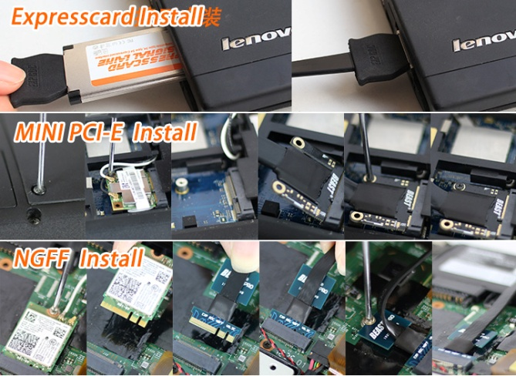
- Set the power installation method (important: equipment installed, restart the notebook, don't live insertion device, otherwise it will burn a notebook or graphics)

The other end is connected to the data line interface board
corresponding to the "reference chart". The HDMI EXP GDC
board can not be connected with other HDMI data line,
otherwise it will cause equipment damage.

The graphics card and power supply installation
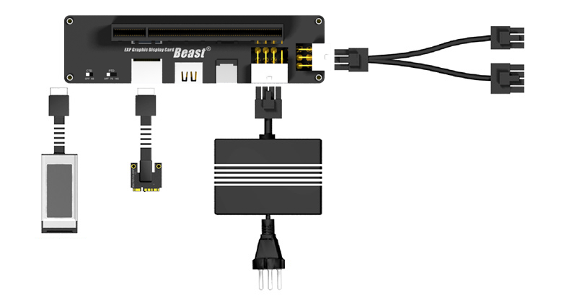

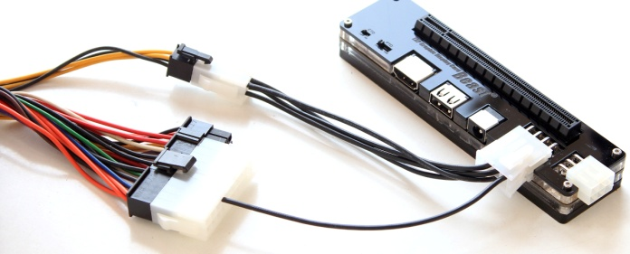
Please ensure that the video card power supply interface fully connected
ATX Power supply installation method

Note: the use of ATX power supply, power supply directly from the power card.
3、System configuration and driver installation
1, The built-in sets + alone models: 1/ is set to UMA in BIOS Graphic Device (Graphic Mode set to Integrated), 2/ Boot to LAN (Network PXE Boot) is set to Disabled. Without this option, see driver unload and disable.
The built-in alone models: uninstall disable built-in alone.
2, The installation Video card driver.

The built-in graphics card unloading and disable。
1, If you encounter graphics conflict, need to disable the built-in alone please note the following specification (first step) DriverUnload and (second step) method of hardware disable.
2, Click "start" - click "control panel", open the "uninstall" to find the corresponding NVIDIA or AMD (ATI) drive, all you need to uninstall clean.
3, After the uninstall is complete, restart your computer.Right click on the "computer" to open the "properties", open the "display adapter", disable the built-in NVIDIA or AMD (ATI) card. (the system may have been identified as "standard VGA graphics adapter").

4、Use display settings
Better use of graphics in need of a simple setup, please see below：
  - Outer use settings
  - Right on the desktop to open the "NVIDIA control panel" (such as the AMD card to open the AMD control panel, click ") into the Physx configuration settings". "Select the Physx processor in the" choice "of corresponding external graphics model".
  - "management of the 3D settings", "global settings" in the "first graphics processor" and select "high performance NVIDIA processor"
  - Blank space on the desktop right click open "screen resolution" can switch settings screen, using a laptop shortcut key or the graphics card can display control panel switch. If not normal recognition to external display please click the "test" - "recognition" to activate the external graphics card.
  - Inner use settings
1, Right on the desktop to open the "NVIDIA control panel" (such as the AMD card to open the AMD control panel, click ") into the Physx configuration settings". "Select the Physx processor in the" choice "of corresponding external graphics model".
2, "management of the 3D settings", "global settings" in the "first graphics processor" and select "high performance NVIDIA processor"
If this method is not the correct use of inner please install the DIY EGPU setting the inner
5、Troubleshooting
1,Start the black screen, no display.
1] some of the motherboard may not support more than 4G of memory, please put down to a single memory memory below 4G.
2] check hardware is connected, the interface contact is good, the use of second-hand graphics please note wipe graphics gold nail.
3] check the graphics card power supply is normal, double 6P interface are connected, the use of ATX power supply whether it conforms to the graphics card power standard.
4] integrated graphics notebook could automatically switch to the external screen display, please pay attention to connect the external display, an external monitor is connected with the output end is connected with the graphics on the outside.
2, After the start of the notebook repeatedly restart
1] notebook upgrade to the latest version of BIOS
2] use of sleep to boot
3, Atart the newspaper 1802 or 1804 error,
1] brush notebook BIOS white list
2] in BIOS to turn off external graphics card used in the port, the corresponding port opened in DIY EGPU.
4, Start the PXE error
1) shut down in the notebook BIOS off the network boot option "BOOT TO LAN"
5, The card in the startup LOGO
1] some of the motherboard may not support more than 4G of memory, please put down to a single memory memory below 4G;
2] the use of sleep to boot
3] in the notebook BIOS off network boot option "BOOT TO LAN"
4] switching in BIOS "Video device 'or" Graphic mode "options, Integrated or UMA to set explicit modes, switchable switching mode, THINKPAD model in PCI EXPRESS PCI-E graphics mode
6, Enter the system blue screen
1] but the add in graphics card into the system uninstall drive with built-in alone, and disable the built-in alone in Device Manager
2] in BIOS to turn off the wireless network card. (this is only for GM45 before platform notebook)
3] we recommend replacing the operating system.
7, In the WINDOWS picture card
1] but the add in graphics card into the system uninstall drive with built-in alone, and disable the built-in alone in Device Manager
2] we recommend replacing the operating system.
8, Enter the system seriously slow, slow response
1] notebook upgrade to the latest version of BIOS
2] used a single memory
3] to unload and disable the notebook comes with video
4] check hardware wiring is correct. Using second-hand graphics card please note wipe graphics gold nail
5] supply is normal, double 6P power supply port card must connect to the power line; power supply using ATX please note whether the 12V output power to meet the demand of the card. Do not use a copycat ATX desktop power.
9, Installed driver can not open after the graphics card control panel
1] in the resolution settings click the "test" - "recognition" to activate the card
2] the memory drops below 4G
3] re install the graphics driver
4] right connect an external monitor
5] uninstall disable built-in alone
10, In the device manager Huang Biao graphics tips
7] install the graphics driver
8] to check whether the normal power supply
9] the memory drops below 4G
10] uninstall disable built-in alone
11] we recommend replacing the operating system
12] DIY EGPU software installation settings for 36BIT
13] DIY EGPU closed DGPU
11, Notebook monitor does not display
15] in the resolution setting switch display
16] using the DIY EGPU set to open IGPU
12, External monitor does not display
17] check the display is connected on the external graphics card
18] display input settings are correct
19] in the resolution setting switch display
20] using the DIY EGPU set to open EGPU
13, Game performance improvement is not obvious
22] Note set graphics optimization
24] the graphics card driver is not installed properly
25] display settings are not correct
26] card supply shortage
27] games support problem, replace the game have a look effect

6、System optimization settings
1, The use of NV graphics card users please drive control panel in PhysX in the graphics settings to the GPU operation can significantly improve performance.
2, Turn off the power management system on the BIOS and PCI-E energy saving options, often cause the system to avoid the time not stagnation.
3, Do not use the system sleep and standby function, which causes the display part cannot restart, some models may not be affected.
4, Strictly in accordance with the instructions to install the use of equipment, not hot pluggable devices.

Advanced features, such as fire, inner double channel need to use DIY EGPU
(Note this software with powerful function, set the cumbersome, we provide tutorials and method of use for reference, according to each different models provided slightly different, if you need to use this software suggestions have the basic hardware and software knowledge, some of this software is unable to provide remote assistance, mainly rely on themselves, the installation and use of a very detailed description, pay attention to own more research research)
Download this connection before you close the security guards and anti-virus software, no virus, please rest assured download.

NOTE: A common type of installation and configuration
Lenovo T410/T420/T430 BIOS-DISPLAY-graphic device Set toINTEGRATED GRAPHICS，
Lenovo Y470/G470/Y480/G480 BIOS-GRAPHIC DEVICE Set to UMA，Disable PXE BBOT TO LAN
Acer 4750G/4752G/5750G BIOS-GRAPHIC MODE Set to integrated，Disable NETWORK BOOT
HP8460P/8470P/cq45/envy 14 beats PTD Set to 7S
HP 2730P PTD Set to 7S Disable PXE BBOT TO LAN or NETWORK BOOT
HP CQ35-219TX Insert EC into a system。
K590C Disable the built-in alone
DELL 4600M Switch can be used in graphics mode BIOS
Lenovo Z470 If you encounter a black boot, turn off the wireless NIC hard switch。
Asus N56 To drive the control panel inside the uninstall built-in alone, then add in graphics card
MSI GE60 Update BIOS to the latest

